About Me
Tonya Calvert enjoys writing children's stories, short stories, and creating watercolor art. She finds inspiration all around her, especially on nature walks and at her favorite destination, the Florida Gulf Coast. She has a BS from Columbus State University and a JD from Atlanta's John Marshall Law School. She paused her legal career to homeschool her children and has never looked back. She's been married to her high school sweetheart for 24 years. They live a blessed life in the Deep South with their three boys.

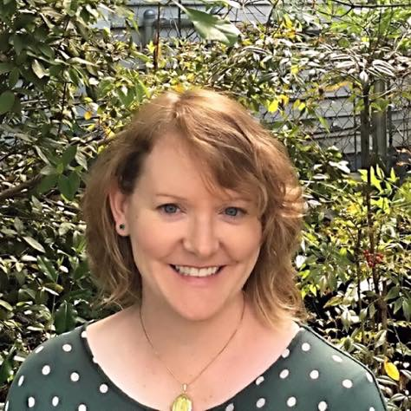

http://www.tonyacalvert.com/
Tonyacalvert1971@gmail.com
https://www.facebook.com/tonyacalvertauthor/
Twitter: @CalvertTonya

About The Book
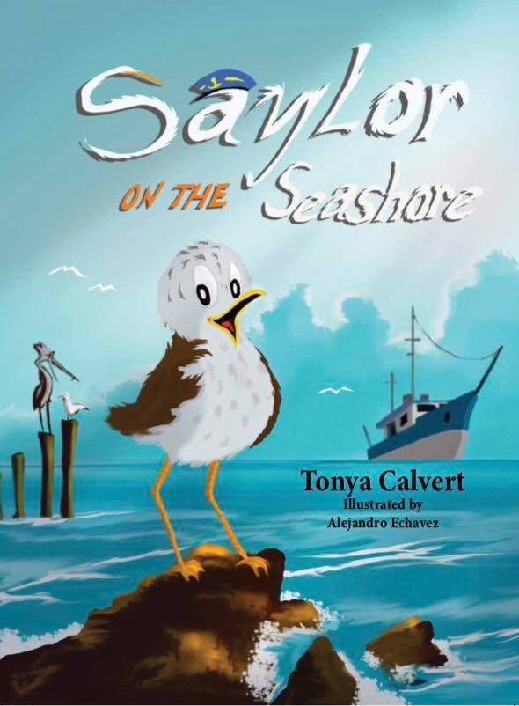

Inspired by True Events
Saylor is a young seagull who is often motivated by his tummy rather than his wits, but living on the Florida Panhandle is dangerous. With fishermen everywhere, a little seagull must rely on what he has been taught to survive. That is, until lunchtime, when Saylor forgets all the warnings his friends have given him. When he finds himself in serious trouble, his friends set out to help. Come to the seashore and cheer them on.
ISBN- 987-1-946101-20-4
https://www.clearforkpublishing.com/coming-soon/saylor-on-the-seashore/

Reviews
“…this book completely transported me to the warmth and sunshine of the Panhandle in the Deep South.”
http://thelikeablelibrarian.com/2017/05/saylor-on-the-seashore/

“Tonya Calvert has captured the essence of a child in Saylor.” Gayle Krause, author.
https://thestorytellersscroll.blogspot.com/2017/04/saylor-on-seashore-review.html

"Librarians, educators, and parents will enjoy its educational value, and children will connect with Saylor..." Vanessa Eccles, author.
http://www.vanessakeccles.com/blog/review-saylor-on-the-seashore-by-tonya-calvert

